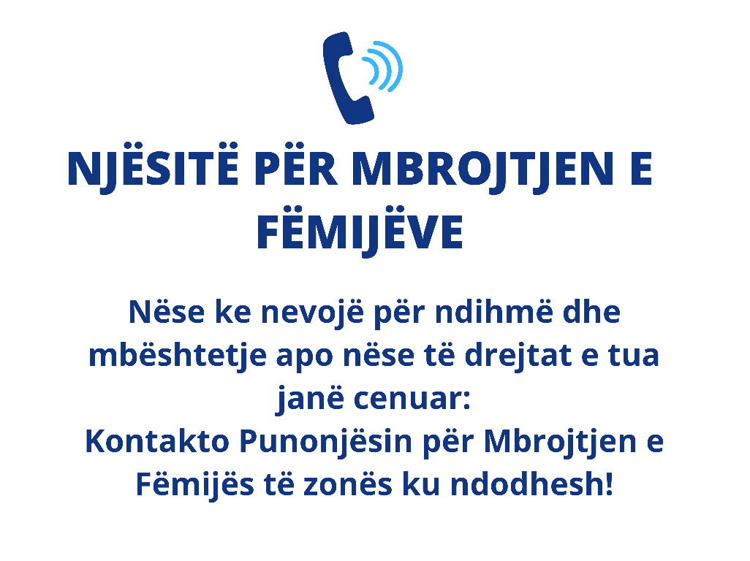
Nr | Bashkia | Nr kontakti
1 | Bashkia Belsh | 0692919515
2 | Bashkia Berat | 0682014296
3 | Bashkia Bulqizë | 0695161725
4 | Bashkia Cërrik | 058122263
5 | Bashkia Delvinë | 0696676906
6 | Bashkia Devoll | 0695576828
7 | Bashkia Dibër | 0685275209
8 | Bashkia Divjakë | 0693749294
9 | Bashkia Dropull | 0884 90058
10 | Bashkia Durrës | 052224796
11 | Bashkia Elbasan | 0692295921
12 | Bashkia Fier | 0696538477
13 | Bashkia Finiq | 0696509496
14 | Bashkia Fushë Arrëz | 0685048975
15 | Bashkia Gjirokastër | 0692951237
16 | Bashkia Gramsh | 0699120128
17 | Bashkia Has | 0695751821
18 | Bashkia Himarë | 0696674826
19 | Bashkia Kamëz | 0686295784
20 | Bashkia Kavajë | 055800807
Nr | Bashkia | Nr kontakti
21 | Bashkia Këlcyrë | 0684330832
22 | Bashkia Klos | 0685675890
23 | Bashkia Kolonjë | 081222644
24 | Bashkia Konispol | 0696804355
25 | Bashkia Korçë | 0695555832
26 | Bashkia Krujë | 051122005
27 | Bashkia Kuçovë | 031122208
28 | Bashkia Kukës | 682633101
29 | Bashkia Kurbin | 0685823052
30 | Bashkia Lezhë | 0694311531
31 | Bashkia Libohovë | 0685388662
32 | Bashkia Librazhd | 0698720506
33 | Bashkia Lushnje | 0693527260
34 | Bashkia Malësi e Madhe | 0693160202
35 | Bashkia Maliq | 0675829885
36 | Bashkia Mallakastër | 031322113
37 | Bashkia Mat | 0686517221
38 | Bashkia Memaliaj
39 | Bashkia Mirditë | 021622233
40 | Bashkia Patos | 0686235260

Nr | Bashkia | Nr kontaktit
42 | Bashkia Përmet | 0692288617
43 | Bashkia Pogradec | 0695606972
44 | Bashkia Poliçan | 0692474138
45 | Bashkia Prrenjas | 059122604
46 | Bashkia Pukë | 0685020740
47 | Bashkia Pustec | 0688291188
48 | Bashkia Roskovec | 038780245
49 | Bashkia Rrogozhinë | 0699316055
50 | Bashkia Sarandë | 0692609325
51 | Bashkia Selenicë | 0689022658
52 | Bashkia Shijak | 0697685535
53 | Bashkia Shkodër | 0673448819
54 | Bashkia Skrapar | 031223090
55 | Bashkia Tepelenë | 0693482422
56 | Bashkia Tiranë | 08000888
57 | Bashkia Tropojë | 021322373
58 | Bashkia Ura Vajgurore | 0692617915
59 | Bashkia Vau i Dejës | 0695813755
60 | Bashkia Vlorë | 0695134450
61 | Bashkia Vorë | 0682918201

